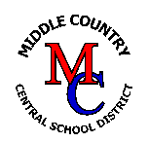**How to View Report Cards on Parent/Student Portal**MCCSD HOW-TO: Last Updated 9/20/2022

**Go to Middle Country website**: [***www.mccsd.net***](http://www.mccsd.net)

* **Click on the PowerSchool icon, on the right-side**

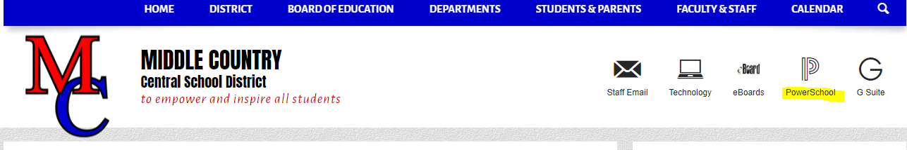

**Select Parent & Student Login:** 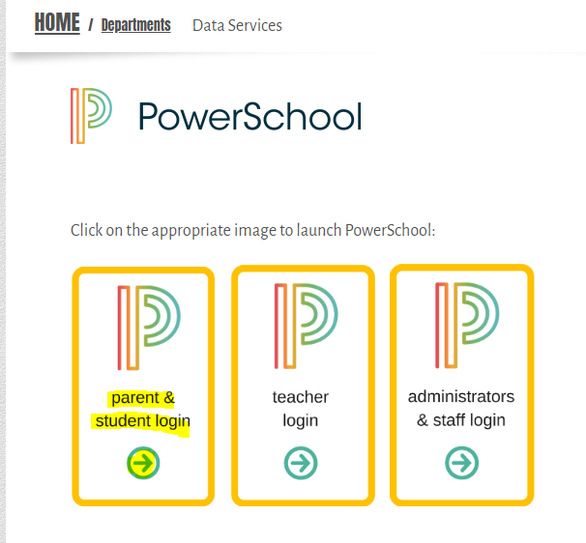

* **Login to the Portal account:**

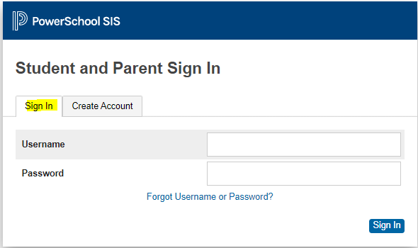

* **Once logged in the Portal, select “Student Portfolio” icon on the navigation bar, on the left-side.**

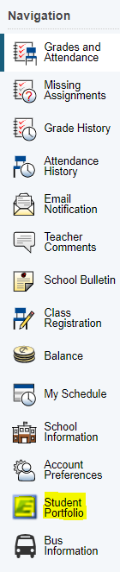

* **A new screen will appear and you see Student Report Cards**
  + **Double- click on Student Report Card**
* **You will then see 2022-2023 Report Card**
* **Click on 2022-2023 underneath Report Card**
* 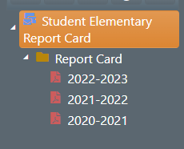
* **After choosing 2022-2023, the most recent report card will appear on your screen. The report card file is in .PDF format and you can now print or download and save.**